Bangladesh Pharmacy Model Initiative (BPMI)

Recommended Collaboration between DGDA and Districts and Upazila/City Corporation Health Authority to Support Inspection and Monitoring of Pharmacies and Medicine Shops

Recommendations Made on a Workshop Held with DGDA Staff at DGDA Conference Hall on 5th October 2016

Submitted to DG, DGDA by Management Sciences for Health –ADS Project

1: Background
As part of development of an inspection and monitoring strategy of Model Pharmacy and Medicine Shops, the Bangladesh Pharmacy Model Initiative (BPMI) project is proposing for mechanisms to improve inspection and monitoring of pharmacies and medicine shops both at central and district/upazila level. The strategy proposes the following components of collaboration.
- Central level DGDA establishment of pharmacy inspection section
- Strengthening/establishment of district/upazila drug committees
- Improving Linkage between DGDA, District and Upazila/City Corporation committees
- Improving financial resource mobilization at central level DGDA, district and upazila
1: Central level DGDA Establishment of Pharmacy Inspection Section
It is proposed to establish a section at DGDA headquarter to oversee activities related to retail pharmacies and medicine shops. Structure, composition and responsibilities of the section are described below.
1.1: Structure of the Proposed DGDA pharmacy inspection Section
Short term implementation
Establishment of Pharmacy Inspection Cell/Wing with the following staff composition;
- Headed by a Deputy Director
- Other staff to include
- One Assistant Director
- Two Drug superintendents
- One Inspector
Long Term implementation
Establishment of Pharmacy Inspectorate with the following staff composition;
- Headed by a Director
- Other staff to include
- Two Deputy Directors
- Three Assistant Directors
- Six Drug Superintendents
Reporting to DGDA
During pilot phase of BPMI project, the wing will report directly to DG, DGDA

1.2: Responsibilities of the Proposed DGDA Pharmacy Inspection Section
The proposed wing/inspectorate will have the following responsibilities. Other responsibilities may be added from time to time as may be found necessary.
- Coordinate with Central/Divisional/District DGDA officials and District, Upazila, Pourashava/City Corporation Committees
- Coordinate and collaborate with MSH on all activities of BPMI project
- Oversee the activities of pharmacy inspection of District/Divisional DGDA Officials.
- Coordinate licensing activities for retail drug shops within DGDA
- Provide legal support to District/Divisional Officials about pharmacy inspection
- Ensure availability of inspection tools at all inspection levels
- Take initiatives to resolve untoward situations as may be arising
- Provide continuous training to inspectors at all levels
- Cooperate with PCB and BCDS on training of drug shop owners and drug shop personnel
- To arrange awareness programs for the stakeholders
- Continuous update the training tools and materials for DGDA personnel related to inspection and monitoring
- Coordinate dissemination of information from DGDA to committee and drug shops at lower level
- Liaison with relevant stakeholders
- Compile annual report on inspections’ outcome and the status of compliance to standing requirements by the operating drug outlets at different levels.
- Compile quarterly reports that find their way to the management meetings for attention and action where needed by this high level;
- Review all inspection summaries reports submitted by the district and actions taken by the districts and acknowledge or respond to reports submitted by the district and local inspectors that need the attention of the head office;

2. Strengthening/establishment of District and Upazila/City Corporation Drug Committees
2.1: Strengthening the District Drug Licensing Committee
It is recommended that the existing District Drug Licensing Committee to be strengthened with focus on revision of the nomenclature, membership composition and responsibilities
2.2: Name of the committee
The name of the committee is proposed to be District Drug Committee. This will allow the committee to perform more functions beyond recommendations for issuing and cancellation of licenses.
2.3: Membership composition
- Civil Surgeon - Chairperson
- Upazilla Health and Family Planning Officer (Sadar) - Member
- Health Officer from Municipality/City Corporation- Member
- Assistant Director, department of Narcotics Control - Member
- Senior Health Education Officer - Member
- Representative from BCDS -Member
- Drug Superintendent - Member secretary

2.4: Responsibilities of District Drug Committee
- To conduct regular scheduled meetings to discuss new applications and operations of existing drug outlets.
- Prepare and submit inspection reports and recommendations to DGDA for information and action as needed.
- Take necessary action within the mandate of the district committee as shall be granted by DGDA.
- Conduct formal enquiry on published news and complains
- Take help from law enforcing agencies as and when required
- Perform other duties as may be directed by DGDA and other higher authorities
2.5: Establishment of Upazila and City Corporation Drug Committee
It is recommended to establish a committee at Upazila and City Corporations to oversee operations of Medicine shops. The names of the committees are proposed to be Upazila Drug Committee and City Corporation Drug Committee. Membership and responsibilities of the committee are described below;
2.6: Membership Composition of City Corporation Drug Committee
- Chief Health Officer – Chairperson
- Medical Officer from CS Office – Member
- Health Officer, City Corporation - Member
- Livestock Officer, City Corporation - Member
- Drug Superintendent selected by DGDA – Member Secretary
2.7: Membership Composition of Upazila Drug Committee
- Upazila Health and Family Planning Officer (UHFPO) – Chairman
- Government Officer selected by Upazila Parishad – Member
- Upazila Livestock Officer - Member
- Health Inspector/Sanitary Inspector – Member
- Pharmacy personnel from Upazila Health Complex – Member Secretary
2.8: Responsibilities of the Upazila and City Corporation Drug Committee
- Receive new applications and conduct preliminary inspections for accreditation/drug license
- Compile and submit inspection reports and recommendations for new applications to the district committee
- Conduct routine inspection of existing drug outlets
- Hold routine meetings to discuss inspection findings, prepare and submit reports with recommendations to the district drug committee
- Take help from law enforcing agencies as and when required
- Perform other duties as may be directed by DGDA and other higher authorities
3.0 : Linkage between DGDA, District and upazila Committees
The following is recommended to be a linkage mechanism for operations of the collaboration between DGDA, District, Upazila and City Corporation Committees
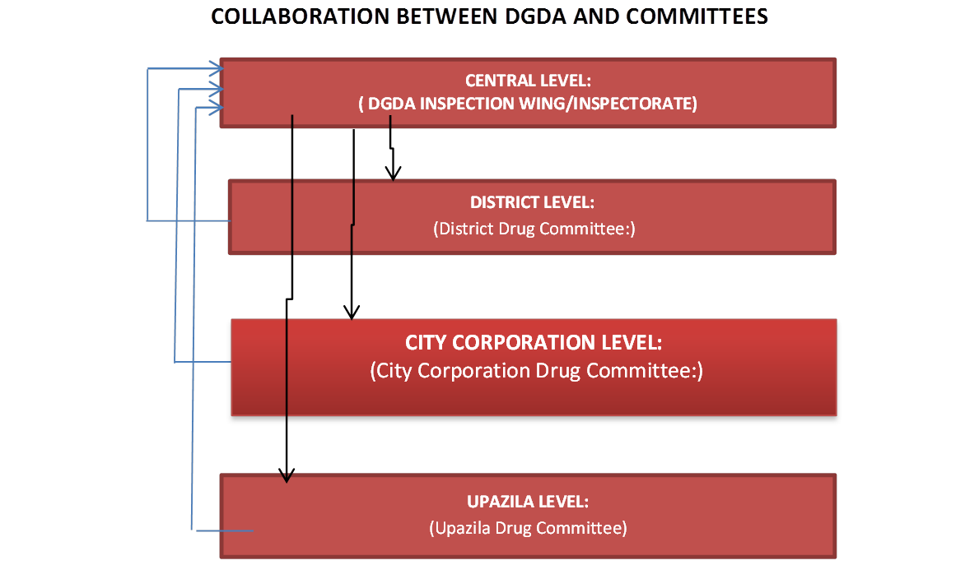

4.0: Improving financial resource mobilization at central level DGDA, district and upazila
4.1: DGDA Resource Mobilization to Improve Inspection and Monitoring
To effectively manage inspection and monitoring of Pharmacies and Medicine Shops, It is ha been recommended to DGDA to explore the following options;
- DGDA to improve on drug shops payment of license renewal fees and explore on possibilities to utilize the collected fees to improve on inspections. Options to support improvement of fees collection include;
  - Collaborate with BCDS to encourage its members on license renewal a
  - Increase inspection visits through district and upazila committees
  - Explore on other fees payment methods such as use of mobile money payments mechanisms
- DGDA to review licensing and renewal fees as the current fee are still low4.3: DGDA to start exploring on possibilities to be able to spend some of the fees collected (~50%) to support inspection activities with prior approval from MOF
- DGDA to start exploring on possibilities to be allowed to use resources collected from services provided (e.g., drug registration, premise accreditation)
- DGDA to include inspection activities by districts and upazila in its annual operation plan budget
4.2: Financial Resource mobilization from District/Upazila/City Corporation and utilization to support the committees
The district and upazila/city corporation committees will require financial resources to perform their duties such as;
- Allowances for inspectors during inspection
- Allowances for committee members during regular scheduled meetings
- Preparation of inspection materials and reports
4.3: Options for sources of funds for the committee will include;
- GOB revenue budget
- City Corporation budget
- DGDA budget support
- Annual operation plans
- Donors support

