THE NATIONAL DRUG AUTHORITY AND MANAGEMENT SCIENCES FOR HEALTH LAUNCH THE ACCREDITED DRUG SHOP (ADS) PROGRAM IN KIBAALE TO IMPROVE ACCESS TO MEDICINES IN THE PRIVATE SECTOR

PRESS STATEMENT NOVEMBER 10TH, 2009.

Access to basic medicines is a problem, especially in rural settings, due to the fact that services being provided through the public health facilities often do not meet the high demand for essential basic medicines and licensed pharmacies may not be readily accessible. For this reason many citizens (about 60%) depend on the private sector Class C drug shops, which are widely accessible in rural and sub-urban areas, for their medicines needs.

Nevertheless, even with the existence of a widely distributed Class C drug shops in the country, there are several problems within the drug shop operations. Some of the identified problems include: sale of prescription drugs which are not permitted to be available in these outlets, sale of unregistered drugs, dispensing being carried out by untrained persons, poor record keeping on the types of drugs dispensed, and poor drug storage. In general, these problems and many others not mentioned contribute to putting the health and lives of Ugandans at risk and also contradict the objectives of the national drug policy and regulations of ensuring access of safe and quality health services for all Ugandans.

In order to resolve these problems, the Ministry of Health and the National Drug Authority in collaboration with Management Sciences for Health (MSH), with funding from the Bill & Melinda Gates Foundation, are initiating a pilot intervention to address some of the identified problems. The official launch of the initiative will be held on November 12th, 2009 at Kibaale town council-Bujuuni grounds, in Kibaale district. The Honourable Minister of Health, Dr. Stephen Malinga, will officiate.

The Accredited Drug Shop program is part of the wider East African Drug Seller Initiative (EADSI) and it builds on MSH’s Strategies for Enhancing Access to Medicines (SEAM) Program, which, in collaboration with the government of Tanzania, launched the country’s successful accredited drug dispensing outlet (ADDO) program in 2003. The program is being implemented as a partnership; the National Drug Authority (NDA) as the lead implementing partner working in collaboration with the Pharmaceutical Society of Uganda, while MSH provides technical support and the Ministry of Health provides overall policy guidance.

A major objective of this intervention is to ensure that individuals living in rural, sub-urban, and underserved areas can access safe and quality medicines from established accredited drug shops that have trained personnel. Key components of this program are expansion of the range of basic medicines including some prescription drugs that are allowed to be sold in accredited drug shops, comprehensive training of all personnel who sell medicines in these drug shops, mobilization of communities on the proper use of medicines, and strengthening of the regulatory and inspection system.

The pilot program has so far achieved the following objectives:
- Training of drug shop attendants in pharmaceutical management and care—up to 205 drug shop attendants, in Kibaale district, have been trained in pharmaceutical care and good dispensing practices.
- Training of 82 drug shop owners in pharmaceutical management and business skills and linking them to micro finance support.
- Strengthening the National Drug Authority’s partnership with the local government and completion of training of personnel to act as local monitors who will report inappropriate activities of drug sellers to NDA for possible regulatory action.
- Training supervision teams to provide guidance to the ADS and ensure compliance to the set regulatory requirements for operating ADS.
- Completing renovation and transformation of up to 70% of the Class C drug shops in Kibaale into Accredited Drug Shops (ADS).
- Providing on-going community sensitization on what to expect from the newly accredited drug shops and proper use of medicines.

Uganda is not alone in this endeavour to improve access to good quality medicines and pharmaceutical services to its people. Our neighbours in Tanzania are scaling up nationwide a similar program known as the Accredited Drug Dispensing Outlet (ADDO) program. The ADDO initiative has improved access to medicines in the rural areas of Tanzania, improved quality of dispensing, and strengthened inspection and regulation of accredited shops.

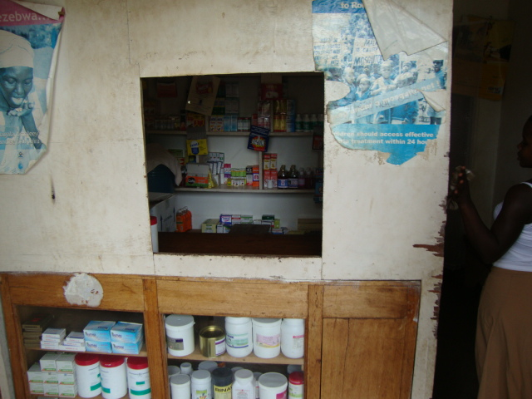
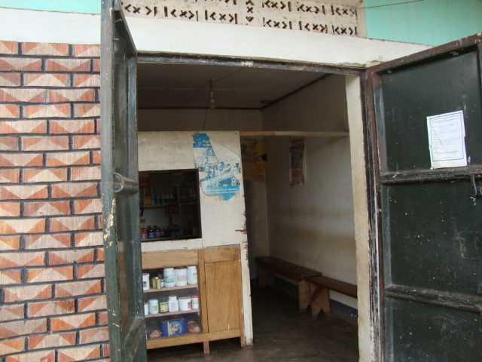

St. Francis drug shop in Mwitanzige before the accreditation process

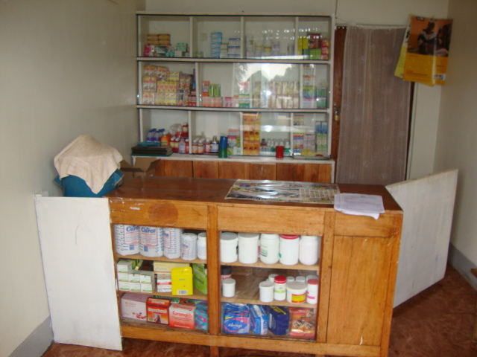
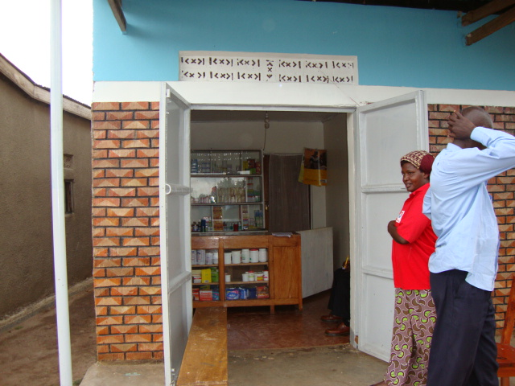
St. Francis drug shop in Mwitanzige after the accreditation process

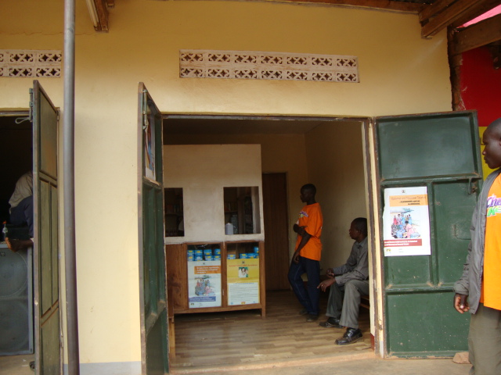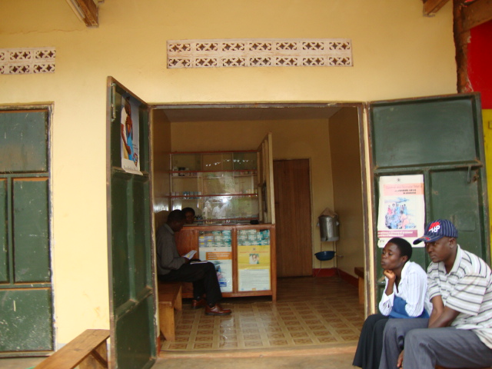
Kayi drug shop in Kakumiro after the accreditation process

Kayi drug shop in Kakumiro before the accreditation process

