
BASIC BUSINESS SKILLS COURSE FOR HEALTH SHOP OWNERS

Health Shops Business Training
Trainee Manual

March 2017

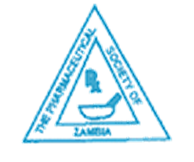

Table of contents
TABLE OF CONTENTS 2
INTRODUCTORY MODULE: GENERAL BACKGROUND AND LEGAL ASPECTS OF DRUG SALE AND USE…………………………………………………………………………………………………………………………..4
BACKGROUND TO HEALTH SHOPS 4
MODULE 1: UNDERSTANDING YOUR HEALTH SHOP BUSINESS 25
SESSION 1: THE BUSINESS ENTREPRENEUR 25
SESSION 2: ASSESSING YOUR BUSINESS 27
SESSION 3: STAKEHOLDERS OF THE Health Shops 30
MODULE 2: LIFE GOALS AND PERSONAL FINANCIAL PLANNING 34
SESSION 1: SETTING GOALS TO REACH YOUR PERSONAL VISION 34
SESSION 2: IMPORTANCE OF MANAGING PERSONAL FINANCES 35
SESSION 3: PRIORITISING FINANCIAL GOALS 36
SESSION 4: THE BUILDING BLOCKS OF SUCCESS 37
MODULE 3: RUNNING A FAMILY BUSINESS 40
SESSION 1: WHAT IS A FAMILY BUSINESS AND WHAT ARE ITS UNIQUE FEATURES? 40
SESSION 2: SUCCESSION PLANNING IN FAMILY BUSINESS 44
SESSION 3: CRITICAL SUCCESS FACTORS IN FAMILY BUSINESS 45
MODULE 4: HEALTH SHOPS BUSINESS PLANNING 47
SESSION 1: INTRODUCTION TO THE CONCEPT OF BUSINESS PLANNING 47
SESSION 2: KEY COMPONENTS OF A BUSINESS PLAN FOR A HEALTH SHOP 48
SESSION 3: KEY COMPONENTS OF THE BUSINESS PLAN 48
SESSION 4: THE BUSINESS FINANCING PLAN 50
MODULE 5: BUSINESS MANAGEMENT 54
SESSION 1: COSTING AND PRICING 54
SESSION 2: BUYING, RECEIVING, AND TRANSPORTING MEDICINES 56
SESSION 3: STOCK MANAGEMENT 59
SESSION 4: MARKETING AND CUSTOMER CARE 64
SESSION 5: BUSINESS LEADERSHIP AND ETHICS 66
SESSION 6: PEOPLE MANAGEMENT 67
MODULE 6: RECORD KEEPING AND BUSINESS FINANCIAL MANAGEMENT 69
SESSION 1: BOOKKEEPING 69
SESSION 2: GUIDELINES FOR INCOME AND EXPENDITURE CONTROL 71
SESSION 3: BUYING AND SELLING ON CREDIT 74

INTRODUCTORY MODULE: GENERAL BACKGROUND AND LEGAL ASPECTS OF DRUG SALE AND USE

Background to Health Shops

Zambia’s Health System
Health care delivery services in Zambia are manned by both public and private sector personnel.
The government provides XX% of all health services offered in Zambia and the remaining XX% is met by private sector service providers.
It is within this context that the Government of Zambia has recognized the need to involve the private service providers in the overall provision of health services to the people of Zambia.
The health care delivery system in Zambia is composed of:
Government health facilities (XX%)
Private institutions (XX%)
Private for profit
- Private hospitals
- Medical centres
- Clinics
- Pharmacies
Private not for profit
- Hospitals
- Medical centres founded on religious backgrounds (e.g., mission-founded health facilities)
One of the objectives of setting up Health Shops in Zambia is to increase access to health commodities, and to quality health services, especially in hard to reach areas. This can be seen in the fact that one of the components of the services offered by Health Shops is to ensure proper and prompt referral of clients to the next level of health care service delivery.
To achieve this, the Health Shop dispenser should be familiar with the referral system and the services offered at each level to avoid any delay in the proper management of clients.
Zambia’s Health Care Referral System

LEVEL III HOSPITAL
LEVEL I HOSPITAL
URBAN HEALTH CENTRE
RURAL HEALTH CENTRE
HEALTH POST

LEVEL II HOSPITAL

The pharmaceutical sector in Zambia
Headed by the Pharmacy Unit under the Directorate of Clinical Care & Diagnostic Services of the Ministry of Health (MOH).
Zambia Medicines Regulatory Authority (ZAMRA) under the MOH is responsible for controlling importation, manufacturing, premises and use of medicines in Zambia.
Health Professions Council of Zambia (HPCZ) is responsible for registration of practitioners, professional practice, pharmacy practice, and training, monitoring and supervision.
Pharmaceutical Society of Zambia (PSZ) and Zambia Pharmaceutical Business Forum (ZPBF) provides advisory services on pharmacy policy issues to MOH.
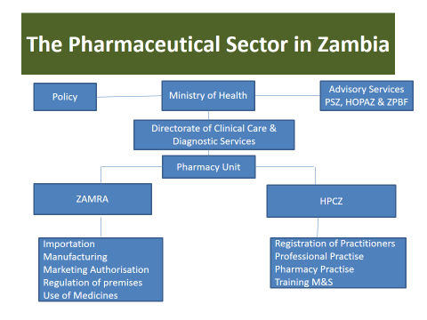
Imported pharmaceuticals
Most of the medicines used in Zambia are imported and a small percentage are manufactured locally.
The biggest percentage of medicines imported into the country come from India and China.
A small percentage come from Europe and the rest of Africa, mainly from South Africa, Kenya, and Tanzania..
Distribution of pharmaceuticals
The distribution of pharmaceuticals in Zambia is through either public or private sources.
Public distribution is controlled by Medical Stores Ltd, which distributes all medicines and health supplies to government large hospitals and also to regional hubs which in turn coordinate the last mile distribution to government health centres and hospitals.
The distributors of pharmaceuticals in the private sector include direct importers and wholesalers.
The direct importers supply wholesalers, which are distributed countrywide, although these are mainly found in major towns and along the line of rail.
Wholesalers then sell the medicines and supplies to retail pharmacies, clinics, private hospitals, Non-governmental organizations (NGO), and faith-based health facilities.
Medical Stores Ltd supply faith-based health facilities supported by Church Health Association of Zambia (CHAZ)

Distribution Channels of Pharmaceuticals in the Private Sector
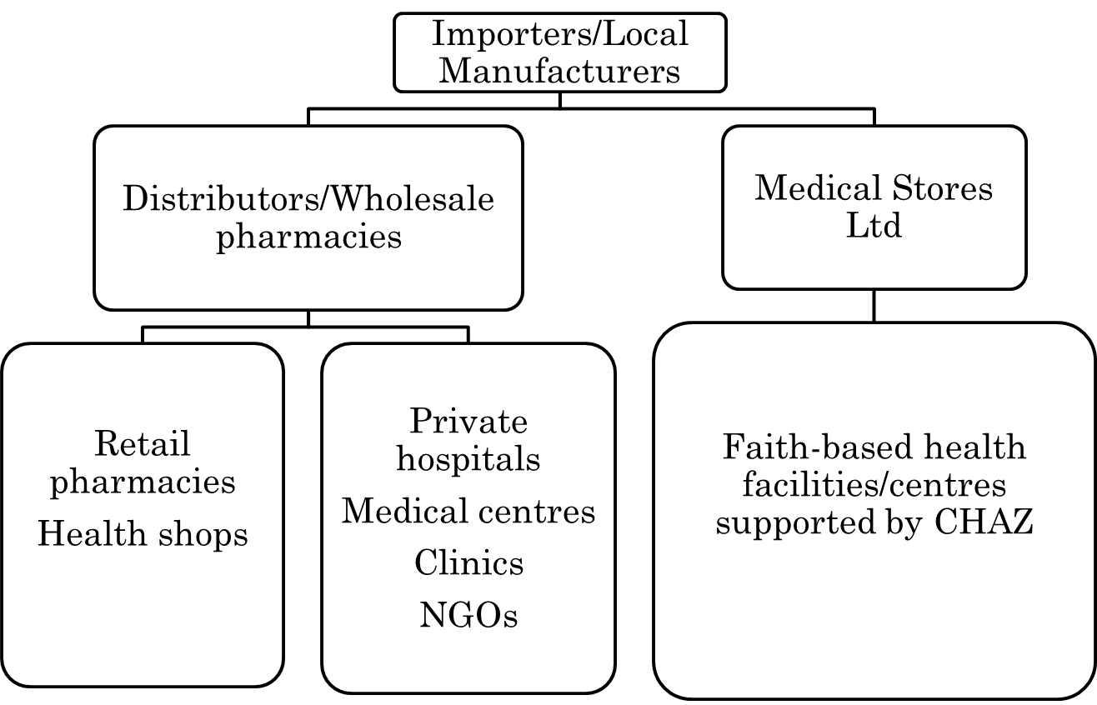
Pharmaceutical services
Private retail pharmaceutical services are mainly concentrated in big towns.
Lusaka, Central, and Copperbelt Provinces have more retail pharmacies.
Distribution of retail pharmacy outlets in other provinces are mainly in the provincial centres and other towns directly on the line of rail.
Retail pharmacies, which are allowed to stock a wide range of both prescription and over-the-counter (OTC) medicines, mainly serve the urban communities or along the line of rail.
This imbalanced distribution of pharmaceutical services has led to the establishment of Health Shops.
According to Statutory Instrument No.12 of 2016, Health Shops are allowed to stock all medicines on the general sales register, including some prescription medicines on the prescribed list that are highly needed in the community and are registered by ZAMRA.
The Health Shops are mainly intended to serve the rural communities that are far from retail pharmacies.
The Health Shop Model
A Health Shop is a primary health care facility or lower level medicines retail outlet that is allowed to sell medicines on the general sales list, including some approved prescription medicines.
Earlier regulation limited the access to medicines.
The Pharmacy Regulatory Agency (predecessor to ZAMRA) in collaboration with stakeholders, eventually repealed the Pharmaceutical Act and successfully incorporated the Health Shops (accredited drug stores) into the new Medicines and Allied Substances Act of 2013 Section 30 (1) in response to poor access to medicines.
The Health Shops are medicine outlets that were introduced in this legislation.
The current Health Shops model is new in Zambia.
The idea of setting up the Health Shops is based on the results from the model tested in Tanzania (the ADDOs), where the results were excellent in terms of medicine access. It was also piloted and is currently being rolled out in Uganda (the ADS).
In Zambia the Health Shops were piloted under the Zambia Access to ACT initiative (ZAAI) model in Kasama, Chama, Chinsali and Lundazi.
In the Zambia model, the operations of Health Shops are regulated by ZAMRA, in conjunction with the District Health Office (DHO).
Besides the ZAMRA, professional bodies and stakeholders with keen interest in the operation of the Health Shops include:
- Pharmaceutical Society of Zambia (PSZ)
- Health Professions Council of Zambia (HPCZ)
- Nongovernmental organizations (NGOs)
- Zambia Pharmaceutical Business Forum (ZPBF)
- Pharmaceutical industry
- Members of the public/entrepreneurs

Why Health Shops?
- To improve the availability of medicines:
- Essential medicines are available and accessible to all communities.
- To improve health care services in communities such as:
- Malaria (testing)
- HIV (testing)
- Tuberculosis
- Family planning (FP)
- Maternal health
- Childhood illness care
- To reduce irrational medicines use and inappropriate practices:
- Prescribing unneeded antibiotics for ailments (respiratory problems, gastrointestinal problems, etc.)
- Injecting medicines when tablets are safer and equally effective
- Poor storage of medicines
- Untidiness
- Dumping of expired medicines
Requirements for accreditation
Retail outlets that meet specific criteria or prescribed guidelines and standards developed by ZAMRA are eligible for accreditation.
Accreditation means: approved by ZAMRA to dispense an enhanced list of medicines and manage selected diseases.
This happens after:
- Passing inspection
- Completing the training component and passing the examination
- Adopting the approved ethical code
Note: Once accredited, the retail outlets are called Health Shops.
The district pharmacist provides local supervision of Health Shop activities and reports regulatory abuse to ZAMRA.
Regular inspection is conducted by ZAMRA.
An accreditation certificate is issued to the successful applicants.
Expectations of the Health Shop
- Purchase stock from licensed wholesale pharmacies.
- Proper storage of medicines.
- Proper dispensing of medicines.
- Management of selected illnesses in both children older than 2 months and adults.
- Early reporting of outbreaks.
- Client education and referral of clients with chronic conditions.
- Referring in cases of danger signs.
- Counselling and initiating women on family planning (FP) methods.
- Counselling mothers on newborn care, nutrition, and immunisation of children under 5 years.
What health conditions can be managed at the Health Shop?
The following conditions can be managed at the Health Shop:
- Management of selected illnesses in children above 2 months and adults
- Management of childhood illnesses (non-bloody diarrhoea, pneumonia, and malaria)- Integrated Community Case Management (ICCM) strategy
- Referring in cases of danger signs
- Education and referral of patients with chronic conditions
- Counselling mothers and dispensing medicines (refills only) for Family Planning
- Counselling mothers on new-born care, nutrition, and immunisation of children under 5 years
- Early reporting of outbreaks
- Uncomplicated malaria in both adults and children
- Upper respiratory tract infections
- Common colds, allergic rhinitis (adults and children)
- Non-severe pneumonia only in children 2 months to 5 years (with no danger signs or chest in-drawing, or stridor in calm child)
- Non-bloody diarrhoea in children and adults except in cases of severe diarrhoea or severe dehydration, or persistent diarrhoea
- Anaemia and malnutrition in children 2 months to 5 years only, except for severe cases as defined in the Health Shops manual
- Sexually transmitted infections (STI) identification and referral
- HIV testing and referral
- Minor skin conditions, such as boils, ringworm, athlete’s foot, scabies, chicken pox, nappy rash, minor cuts, and skin allergies
- Selected eye conditions
- Treatment of lice
Benefits of Health Shops
- Health Shops will be allowed to stock medicines and other health-related commodities beyond what is generally allowed by ordinary retail outlet.
- Health Shop dispensers and owners will be trained in business management, medicines management, and client care.
- There will be a public awareness campaign so that clients will know that Health Shops provide good care and are a good place to seek help.
- There will be supportive supervision and regular monitoring.
ETHICS, LAWs, & REGULATIONs in HEALTH SHOPS
General Definitions
Laws
- Laws are rules that govern human conduct and are binding to all persons within a given state or nation.
Regulations
- Regulations are more specific rules controlling or restricting a specific activity.
Guidelines
- These are instructions on how to implement or to enforce the laws.
Policy
- A policy is a point of reference or general understanding to guide or influence decision making regarding long-term actions.

Drug (medicines) policy
- Is a policy that is focused on improving the availability and accessibility of medicines, e.g. a policy on the accreditation of Health Shops.
Regulation of medicines
A set of laws, regulations, guidelines, and policies that provides a basis for control over the manufacture, distribution, marketing, dispensing and surveillance of these products.
The regulation of medicines is important due to the following:
- Patients’ dependence on health workers for medicines advice.
- Conflict of interest.
- Possibility of the medicines causing harm, including herbal medicines
- The increased number of individuals involved in the manufacture and sale of medicines.
The aim of regulation is:
- To ensure that quality medicines are available to retailers and consumers.
- To safeguard the welfare of the patient and the community.
- To ensure that qualified personnel are involved in the handling of medicines.
To ensure that medicines are supplied and sold in suitable premises and using suitable equipment.

Regulation of Health Shops
The regulatory body for the Health Shops is ZAMRA, which is mandated by the Medicines & Allied Substances Act No. 3 of 2013. ZAMRA works with the DHO and other stakeholders (e.g. local government, professional bodies, NGOs) to support its functions.
ZAMRA’s functions include:
- Set standards for the operation of Health Shops and pharmacies.
- Register and regulate pharmacies, Health Shops and Agro-veterinary shops.
- Regular inspection to ensure compliance with set standards and practices.
- Approved essential medicines list; determines which medicines are to be stocked in Health Shops.
- Controls the storage, dispensing and sale of medicines and allied substances.
- Verifies the safety, quality & efficacy of medicines and allied substances

The regulation of the Health Shops at district level will be done with the support of district authorities as follows:
- The DHO in every district is mandated to oversee all health-related activities and ensure that they meet the required standards.
- The DHO will delegate local teams to regularly inspect and monitor the health-related activities in both the public and private sectors.
- The licensing and accreditation of Health Shops will be performed by the Regulatory service centres sitting at PACRA or Local Authority offices at the district levels.
Health Shop owners/dispensers can be encouraged to form associations for Mentorship and Lobbying on their welfare but not to be involved in regulation and law enforcement.
Legal Requirements for Setting up and Operating a Health Shop
Licensing and operations
The process for application and obtaining of a permit from ZAMRA is:
- Obtain application forms for permit from ZAMRA
- Correctly fill and submit completed forms to ZAMRA.
- Wait for ZAMRA inspection.
- ZAMRA conduct the inspection
- Only upon fulfilling all requirements will a permit be issued
Note: The inspection process will be supported by the district health office.
More detailed outline of the process and excerpts of the required forms can be found in the Health Shops Regulations, 2016 (SI No.12 of 2016)
Application, inspection, and accreditation process
Steps | Responsible body/reason
- Inspection of the premises | - ZAMRA
- Training of Health Shop dispenser and owner | - Authorized training institution  - Dispenser should have a minimum qualification of Grade 12 certificate to qualify for training.
- Issuance of permit to operate the Health Shop | - ZAMRA  - This is done when the Health Shop has met the minimum requirements.
- Regular monitoring and supportive supervision | - Team comprising: ZAMRA, DHO, MOH, PHO, HPCZ, PSZ & Local Authority  - The objectives are to ensure that the Health Shop dispensers and owners perform and conform to the regulatory guidelines, and to provide onsite support and mentoring.  - This team shall make quarterly supervision visits using a standard checklist and will be trained to supervise and write reports.

Standards for operating a Health Shop
Standards are minimum requirements. The following are the standards for proper running of a Health Shop. They apply to:
- Personnel
- Premises
- Dispensing
- Record keeping and documentation
Standards for personnel
- Trained Health Shop dispenser
- Dress in a professional manner
- Not to work under the influence of alcohol.
- Observe high standards of personal hygiene.
- Be of sound mind.
- Behave professionally.
- Observe the guidelines set by the ZAMRA.
- Health Shop dispenser must have written a commitment letter to operate with a particular Health Shop.
- Undergo regular continuing medical education.
Standards for dispensing
- Availability of dispensing materials.
- All medicines stocked must be registered with the ZAMRA.
- All the medicines in the Health Shops should be stored according to the manufacturers’ guidelines.
- Should not dispense expired medicines.
- Should be able to identify and refer complicated cases.
- All prescription medicines to be dispensed on a written valid prescription.
- Maintain proper records of dispensed medicines.
- Medicines should be dispensed in a proper container that is clearly labelled.
- All medicines should be given with proper instructions.
Standards for premises
- Be of permanent nature.
- The roof should not be leaking and should have a ceiling.
- Space should be big enough (at least 24m²) to carry out proper dispensing.
- The walls and floors should have smooth surfaces.
- The walls should be painted white or any other bright colour.
- Availability of water, latrine.
- Availability of sign post for Health Shops.
Standards for record keeping
- All invoices and receipts should be recorded in the purchase medicines book and the original receipts should be kept.
- All prescriptions should be recorded in the Health Shops dispensing log book and the records kept for at least 2 years.
- A record of expired drugs should be kept.
- Availability of the files of communications from the ZAMRA and other regulatory authorities.
Reference materials

- Zambia National Formulary (ZNF ) recent edition;
- British National Formulary (BNF) where applicable, recent edition preferred;
- Medicines and Allied Substances Act (No.3) of 2013;
- Health Professions Act No. 24 of 2009;
- Guidelines for Health Shops;
- Standard Treatment Guidelines;

- Standards of pharmacy practice;

- Health Shop regulations, 2016 (NB: ensure it has the approved list of medicines for sale in Health Shops);

- General Sales Medicines registered by ZAMRA

Health Shops personnel code of ethics

- Should be honest and have integrity
- Ensure client’s wellbeing at all times
- Respect for the client
- Should not discriminate against clients
- Ensure confidentiality and privacy
- Provide quality medical services
- Collaborate with other health workers
- Should not engage in the sale of illegal/ government medicines
- Should participate in health promotion activities

The PRESCRIBED LIST OF Medicines FOR HEALTH SHOPS
The Health Shops can stock and dispense medicines from the general sales medicines list as well as from the Health Shops prescribed medicines list below, which is found in the Health Shops regulations. The list takes into consideration the prescribing practices in line with the Standard treatment guidelines, malaria treatment guidelines, and STI guidelines.
A consideration has also been made to ensure that the public has reasonable access to the most essential (key) medicines needed to treat the common diseases found in the community. It is desired that all medicines be stored and dispensed as a patient pack, which is defined as a quantity of medicines sufficient to treat a single patient for a specified condition.
Note: Health Shops are not allowed to stock, dispense, or administer injectable medicines.
Drug and form | Intended ailments

Medicines for Asthma
Salbutamol tablet 2 mg | Wheezing & difficulty breathing
Salbutamol inhaler 100mcg/dose | Wheezing & difficulty breathing
Antibiotics
Amoxicillin capsules/tablets 250 mg | Respiratory tract infections (RTI) & urinary tract infections (UTI)
Amoxicillin oral suspension 125 mg/5 ml &250 mg/5 ml | RTIs, UTIs
Co-trimoxazole tablets 400/80 mg | RTIs, UTIs
Co-trimoxazole suspension 240 mg/5 ml | RTIs, UTIs
Doxycycline capsules/tablets 100 mg | Gonorrhoea, pelvic inflammatory disease
Metronidazole tablets 200 mg | Protozoa diarrhoea, trichomoniasis, dental infections
Tetracycline Hyclate Ointment 1%
Silver sulfadiazine cream 1% w/w | Wounds and burns
Anti-helminthics
Albendazole tablet 400 mg | Intestinal worms
Anti-Inflammatory/Analgesics
Ibuprofen tablet 200 mg | Pain and fever
Hydrocortisone cream 1% | Eczema, nappy rash, insect bites
Paracetamol tablets 100mg, 500 mg | Pain and fever
Acetylsalicylic acid tablet 300 mg | Pain and fever
Anti-fungal
Nystatin oral suspension 100,000 IU/5 ml and 100,000IU/ ml | Oral candidiasis
Clotrimazole cream 1%, 10% | Fungal skin infections, e.g., ringworms
Clotrimazole vaginal tablets 100mg/ 500mg | Vaginal candidiasis
Antimalarials
Artemether-Lumefantrine tablets 20/120mg | Uncomplicated malaria
Laxatives
Bisacodyl tablets 5mg | Constipation
Anti-histamines
Cetrizine hydrochloride tablets 10 mg | Skin itching, common cold & allergy
Cetrizine hydrochloride oral solution 5 mg/5 ml | Skin itching, common cold & allergy
Chlorpheniramine maleate tablet 4 mg | Skin itching, common cold & allergy
Chlorpheniramine maleate syrup 2 mg/5 ml | Skin itching, common cold & allergy
Oral Contraceptives
Ethinylestradiol + Norethisterone tablets 0.03mg/0.3mg | Family planning
Ethinylestradiol + Levonorgestrel tablets 0.03mg/0.15mg | Family planning
Minerals/Vitamins
Vitamin B Complex tablets | Vitamin supplementation
Zinc sulphate tablets | Diarrhoea in children
Fluids and Electrolytes
Normal Saline IV 0.9%, 1 litre
Ringers Lactate IV 1 litre

MODULE 1: UNDERSTANDING YOUR HEALTH SHOP BUSINESS

Session 1: The Business Entrepreneur

An entrepreneur has the following characteristics:

- Creative
- Knowledgeable
- Open-minded
- Very careful planner
- Persistent

A business entrepreneur undertakes the following actions:

- Identifies a need in society.
- Identifies a solution to address that need.
- Takes calculated risks to invest to meet the need.
- Makes profits if he/she manages the business well.
- Provides employment to others through his/her business.
- Contributes to government revenue by paying taxes.
- Contributes to community welfare.

A Health Shop Owner is an Entrepreneur
We will consider business person and entrepreneur to mean the same thing.

Does drug shop business fit in the above description? Yes, it does. It is therefore a business or an enterprise. Health Shop owners and sellers are businessmen and business women. For example:

- You identified the need in the community: people need medicines to treat illnesses and diseases.
- You took the risk to start a drug shop. We call it a risk because you are not sure whether the business will make profits or not. Thieves can break in and steal the medicines, the building can catch fire, medicines can expire without being bought and any other bad thing not expected. This is what is called a risk.
- You make profits when you manage your business well.
- You incur losses when you make mistakes in managing the business.
- You employ people in your business.
- You pay taxes either as a business (directly) or indirectly through purchasing other goods.
- You contribute to community welfare from your income, for example, by contributing to weddings, funerals, and other fundraising activities.

Motivations of an Entrepreneur
The motivations of an entrepreneur are central to the success of his or her business. It is useful to reflect on why you started your Health Shop business.

- Was it to earn profits?
- Did you desire to serve the community?
- Was it the only business opportunity out there?
- Do you have particular skills, training qualifications, or talents that are unique to this type of business?
- Were you encouraged by a friend or family member?
- Did you want to create a business opportunity for a wife or child or relative?
- Did you want to employ others?

Keys to Business Success
Whatever your reasons are to start your Health Shop business, there are four key things that will lead to business success:

- The entrepreneur must love the business.
- The entrepreneur must be committed to the quality of the business.
- The entrepreneur must be driven to improve and expand the business.
- In short, the entrepreneur must be motivated to run the best business possible.

To be successful, the Health Shops must be “doing good and doing well.”

A Health Shop is a special and unique type of business. It combines making money and helping to improve – maybe even helping to save – the lives of others. One cannot succeed without the other.

- If you focus on making profits at the expense of providing affordable and effective medicines and quality customer service, your customers will not be satisfied and it will be difficult for the business to do well.
- If you focus only on improving and saving lives, and do not pay attention to making a profit, you will soon run out of business.

A successful Health Shop business owner must balance “doing good” (helping improve or even save the lives of customers) and “doing well” (making some profit) to succeed in his or her business.

Remember: Customers who buy affordable quality medicines from your business are a big asset because they will market your business!

Health Shop owners require specific skills to manage medicines, clients, and their businesses so that they are profitable and sustainable.

Summary

- A Health Shops is a relatively small business that has the responsibility of helping their customers have access to simple medicines.
- A Health Shops is still required to run profitably to ensure its survival. It therefore cannot afford to ignore the basic requirements of any profitable business.

Session 2: Assessing Your Business

To understand whether your Health Shop has the potential to be successful, you should assess the current status of your Health Shop and the business environment in which it operates. Your Health Shop was primarily established to serve the following parts of your business environment:
- Your primary customers
- Your suppliers
- The leadership in your community
- Local government

The status of your business is best determined by examining its internal strengths and weaknesses as well as the external threats and opportunities for your Health Shops. The process of examining them is called a SWOT analysis. SWOT stands for:
- Strengths
- Weaknesses
- Opportunities
- Threats

Strengths of your Health Shop
The strengths of your Health Shop are all the positive attributes that your business has. Strengths are within your control. They are all the things your Health Shop does really well, all the financial and non-financial resources you have, and all the advantages you may have over your competitors.

Examples of the strengths of a business can include:

- Available capital (money) and equipment
- Access to credit
- Clear and sound business structure
- Well-defined financial and non-financial systems
- Knowledgeable, experienced, skilled, and dedicated employees
- Business contacts and supportive business networks
- Existing channels of distribution of goods and services

Weaknesses of your Health Shop
The weaknesses of your Health Shop are all the things your Health Shop does not do well (in other words, the areas that need to be improved), but are factors that are within your control. These are usually factors that affect your ability to obtain or maintain a competitive business edge.

Examples of the weaknesses of a business can include:

- Lack of skilled and competent personnel
- Limited financial and non-financial resources
- Lack of access to technology
- Lack of experience in the pharmaceutical industry
- Poor business location

Opportunities for your Health Shop
Opportunities are external favourable circumstances, factors, and conditions that your Health Shop can take advantage of to continue existing and prospering. Opportunities are important contributors to why your Health Shop exists. For example, the need for affordable and accessible medicines created an opportunity for you to establish your Health Shop. Opportunities are external to your Health Shop business.

Opportunities for a business can be:

- Customers that need affordable and accessible medicines
- Training opportunities
- Favourable business policies
- Tax breaks
- Cheap labour
- Business networks
- Low interest rates from banks and other microfinance institutions

Threats to your Health Shop
Threats are all the external factors beyond your control that can place the survival of your Health Shop at risk! Although you have no direct control over threats, it is important to develop plans to address them.

Examples of the threats to a business can be:

- Competition (always a threat because you are all targeting the same customers)
- Sudden price increases by producers, manufacturers, and suppliers
- Unfavourable governmental regulation and policies
- Bad economic situations
- Changes in consumer taste and preferences
- Introduction of new technologies or medicines that may make your products and services irrelevant
- Unfavourable currency fluctuations

Summary
- Strengths are the positive aspects internal to your business, the value of your Health Shop.
- Strengths are your competitive advantage.
- Weaknesses are the negative aspects internal to your Health Shop.
- Opportunities are advantages in the environment that can contribute to your business.
- Identification of potential threats will help your Health Shop to proactively develop a contingency plan.
- The opportunities and threats are a description of your business environment.
- The internal strengths and weaknesses, compared to the external opportunities and threats, offer information about the current status and potential of your Health Shop business.
- The strengths of your Health Shop must be used to take advantage of the opportunities ahead and minimize the harm that threats may cause.
- Weaknesses must be minimized or eliminated.
- The value of the SWOT analysis is to assess the biggest value of your Health Shop (strengths), the most promising opportunities, and identify crucial inhibiting issues that can affect the profitability and growth of your Health Shop.

Session 3: Stakeholders of the Health Shops

Stakeholders are all the people, entities, organizations, and players that your Health Shops must relate to, either directly or indirectly, for its operations, profitable growth, and sustainability. The key stakeholders for your Health Shops are in eight categories:

- Customers
- Suppliers
- Service providers
- Staff
- Bankers
- Shareholders
- Family
- Community/Government

Each of these stakeholders has different expectations from your Health Shops business and therefore also influences your business.

Details About your Stakeholders
- Customers
Customers expect quality medicines, good prices, and quality service. They are the reason why your Health Shop exists! The following three factors are very important for the success of your business:
- Medicines must be of the best quality available if they are to help treat and cure disease.
- Customers expect to be able to afford the medicines that are available.
- Customers also expect to be served in a respectful, competent way.

- Suppliers
Suppliers are the people who sell you the products and services that you in turn sell to the market. They want your business to succeed because it means more business for them. They expect a good business relationship, especially timely payment when they supply medicines on credit. Suppliers are one of the sources of business finance. In summary, they expect that:
- The business succeeds
- A good business relationship
- Timely payment for goods

- Staff
Staff are the people employed to operate the business. They expect salaries, benefits, and good treatment. Staff could be family members employed in the business or people hired from outside the family. They are an important factor in determining the success of the business. In summary, they expect:
- Salaries
- Benefits
- Respectful treatment

- Banks and microfinance institutions
Banks and microfinance institutions are important partners to every business. They provide safe custody of your money, give you credit, handle your payments and receipts, and provide financial statements and other services. Your business needs friendly bank services. Maintaining a good image with your bank is very important. In summary, they expect:
- That your business will succeed
- Timely payment of debts

- Shareholders
Shareholders are the people who own the business. They are the entrepreneurs. There may be:
- A sole owner who is also managing
- An owner who employs others
- More than one business owner

Most Health Shops are owned by individuals. They provide the capital and other key necessary things to start the business. They enjoy profits when the business is well managed but also suffer losses when the business is poorly managed. Business owners expect to make a profit and often hope that the business will grow and expand beyond where it started. In summary, they expect:
- To make a profit
- Perhaps to expand/grow the business

- Service providers
Service providers are all the individuals and entities that service your business. These include:
- Your energy provider
- Your water and sewage provider
- Your telecommunications provider
- Your insurers
- Your auditors
- Your security services
- Your transporters

In summary, they expect:
- Timely payment for services
- Regular orders

- Family
Family is another key stakeholder. Most Health Shops are family businesses. The family expects its living to come from the business. Children expect school fees, food, clothes, medical care, and other needs. In summary, the family expects:
- That its living will come from the business
- That the children will have school fees, food, clothes, medical care, etc.

- Community or Government
Community or government are not necessarily your direct customers. They are stakeholders in the business because the contribution you make to the community comes from the business. This contribution includes support for community projects (such as water wells, boreholes, feeder roads, schools, churches, or mosques) or social events (such as weddings and funerals). The government expects taxes from your business (direct or indirect). This stakeholder category is also responsible for shaping a favourable policy for the business environment. In summary, they expect:
- Support for community projects
- Support for social events
- Taxes

Summary

- Service providers are all the individuals and entities that service your business.
- Customers are the reason why your Health Shop exists! They buy your products and services.
- Suppliers are the people who provide you with the goods and services you sell to the market.
- Staff/employees are the people employed to operate the business.
- Financial institutions are important partners for every business. They provide you with financial services, like banking services.
- Shareholders are the people who own the business.
- Most Health Shops are family businesses.
- Governments are stakeholders in the business because the contribution you make to the community comes from the business. Government also influences the policy and business environment in which your Health Shop operates.

MODULE 2: LIFE GOALS AND PERSONAL FINANCIAL PLANNING

Session 1: Setting Goals to Reach Your Personal Vision
A vision is the mental picture of what you want. As adults, we have a vision of what we want our lives to be―where we will live, how we will live, what we will do with our lives, etc.
To achieve our vision, we set goals―personal goals and financial goals. Setting goals means identifying where you want to go, what you want to be, when you get there, why you want something, and knowing how you will get what you want. For example:

- Where do you want to be in the next five years?
- What type of person do you want to be married to?
- How many children do you plan to have?

Goals are clear targets that you would like to achieve. Financial goals are specific financial targets you have.

Goals help you to achieve a vision. A vision is the ideal imagined reality you aspire to achieve. A vision is likened to a dream. For example, if your vision is to be debt-free, then your financial goals will help you set priorities and financial targets to ensure your dream for financial freedom.

Relationship Between Life Goals and Financial Goals

Life goals have a relationship with financial goals. You can only achieve life goals when you attain financial goals.

Personal Goals in Life

Examples of non-financial goals include:

- Family size
- Education
- Insurance
- Standard of living
- Religious affiliation
- Marital Status

Financial Goals

Examples of financial goals include:

- Servicing a family budget
- Paying for a new car
- Obtaining a personal education loan
- Buying a house on mortgage terms
- School fees
- Paying your wedding costs
- Paying up your debts

The goals in your life influence the nature of financial goals you set. Your personal goals, therefore, determine how you plan and use your finances.

Summary

- Setting goals in life is a key to success.
- Personal financial goals are derived from personal goals.
- A goal has four key elements: where, what, why, and how.

Session 2: Importance of Managing Personal Finances

Why Do We Need to Plan and Manage Our Personal Finances?

Financial literacy is the capacity to plan and manage personal finances. A financially literate individual is able to identify the amount of money he or she needs at key stages of life, develop strategies for earning the money, and use money earned in a productive, profitable, and sustainable manner.

Benefits of Personal Financial Planning

- It helps individuals to be organized achieve financial independence.
- It helps individuals to benefit from the use of limited resources.
- It furthers the individual’s progression to self-reliance.
- It supports vision, discipline, enterprise, investment, innovation, and responsibility.

Summary

- Set financial goals.
- Prioritize your financial goals.
- Determine the way you will reach your financial goals.
- Have realistic expectations.
- A financially literate person understands the importance of budgeting, savings, and investment, and has the right attitude to managing his or her personal finances.

Session 3: Prioritising Financial Goals

The achievement of goals is dependent on careful planning, hard work, commitment, and self-discipline. The achievement of financial goals is affected by your personal goals and priorities, and these are further influenced by age, socio-economic environment, and clarity of vision. Prioritisation of personal goals in general, and personal financial goals in particular, is a prerequisite to successful attainment of both financial and non-financial goals.

The achievement of your personal financial goals, your planning, and your financial management behaviour are all influenced by your personal priorities.

Personal Priority Table

Age | Personal Priorities | Financial Priorities
Teenager to young adult  (15-25 years old) | Doing well in school, dating, partying, spending on the latest items/fashion, etc. | Receiving and spending  money
Young adults  (25-35 years old) | Embarking on a career, earning lots of money, independence from parents, getting married, starting a family, moving out even if it means renting an apartment, young children’s health, spending on the latest items/ fashion, buying first bicycle/ motorcycle or car | Spending on non-priorities, especially to impress others, and earning an income. Some have started planning for savings and investment.
Adults  (35-45 years old) | Buying or building a first home/ second home, stop having children, going back to school, contemplate a career change, school fees for the children and seeing them through school, paying insurance and life insurance plan, financial stability through return on investments, expanding social and professional networks, marital stability, handling teenage children. | Earning an income, savings and starting to investment in real estate, shares, bonds, treasury bills and business, start investing for children.
Mature adults  (45-55 years old) | Children’s university education, good health, career consolidation, children’s career success, children’s social success as young adults, family succession planning, contributing to social development. | Tripling income, savings, and consolidating investments made in real estate, shares, bonds, treasury bills and business.
Extremely mature adults  (55-65 years old) | Preparing for formal retirement through further consolidation of career and business investments, return on their investment in children’s education, continued good health, continuous consolidation of social and professional networks, investing in society/giving back, the fate of the next generation, remaining relevant and productive. | Health insurance payments, and receiving maximum returns on investments made throughout career, like real estate income, shares, etc.

Summary

- It’s never too late to set financial goals or personal goals. You can start now!
- Personal goals inform financial goals.
- “Written goals are evidence of potentially achieved goals.”
- An effective plan must have prioritized goals.
- Goals must be specific, measurable, achievable, realistic, and time-bound (SMART)

Session 4: The Building Blocks of Success

Developing and Managing Your Personal Budget

You need to plan for expenditures, manage your expenditures, and compare your expenditures against your income on a monthly basis.

Your Budget

Your budget normally covers fixed and variable costs.

Fixed costs are all those monthly expenses that have to be met. They include the following:

- Electricity
- Rent
- Water
- Insurance
- School fees
- Loan payments/ advances
- Medical expenses for chronic conditions like hypertension
- Tithe
- Food
- Communication/airtime
- Transport

Variable costs include all those expenses that one can generally live without during the month. They include the following:

- Clothing
- Hair care
- Entertainment
- Weddings
- Funerals
- Emergency medical expenses
- Social pledges
- Gifts
- Television (Digital Satellite Television [DSTV], GoTV)

Savings

- Plan to save 10% of your income.
- Ensure you have a “safe margin” of three months of income (as savings).

Example: Managing personal income and expenditure
1. List all your sources of monthly income.
2. Calculate your total monthly income.
3. Review your monthly budget and list all your monthly expenses.
4. Determine if your income has covered all your expenses (including savings, investments, and tithes).
5. In case you have a gap between income and expenses, develop a strategy to close that gap.

Summary

- Keep track of your income versus actual expenditure and avoid an income versus expenses gap.
- Exercising restraint and self-discipline is necessary for successful financial planning and management.
- You must aim to save a tenth of your income over and above your tithe! Discuss income and expenses with family.
- Live within your means.
- Maintain a good credit history with your financial institutions.
- Avoid credit as much as possible.
- Credit must only be used for a business investment or a real life-threatening emergency situation.
- Continuously explore ways of diversifying and increasing your income.
Sample planning approach steps
1. Determine concrete goals.
a. State your broad goal. (Example: buy a home).
b. Determine the specific pieces to achieve that goal. (Example: down payment amount.)
2. Create an action plan.
a. Define how to achieve each of the specific pieces of the goal.
b. Determine how much to save each month and where to invest the money.
3. Evaluate performance.
a. Check on steps 1 and 2 at least once a year.
b. Make adjustments, as needed.
4 Decide on a future course of action.
a. Continue with the present overall plan.
b. Adjust the overall plan, as needed.

MODULE 3: RUNNING A FAMILY BUSINESS
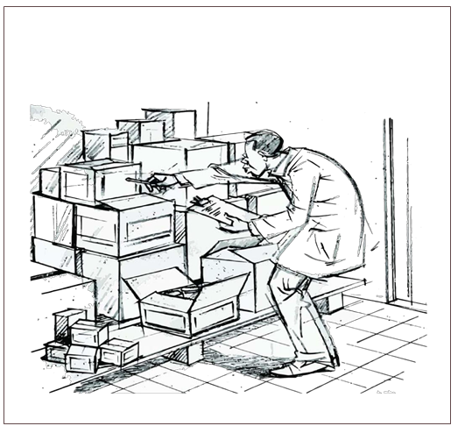

Session 1: What Is a Family Business and What Are Its Unique Features?

A family business is any business undertaking aimed at yielding returns for the survival of a group of people, termed as a relationship, and not necessarily based on blood only.

What are the Family Business Challenges in Africa?

One challenge is that internal stakeholders may have high levels of expectations from the family business even if they do not contribute to the wealth creation process.

Family members are loved unconditionally. But as business members, they must be dealt with conditionally. If family members are also business members, the business may face certain challenges. Some of those challenges are listed below, along with potential remedies.

Prominent Challenges | Occurrence Risk | Potential Remedy
Mistrust, dishonesty in family and employees | High | Behavioural change, promoting openness, honesty, kindness, reliably and competence
Selfishness in the family | Average | Promoting solidarity
Lack of family cooperation | Average | Promoting solidarity
Low capital & high withdrawals | High | Establishing a savings culture
Lack of skills in the family | Average | Obtaining adequate skills
Lack of creativity in the family | Average | Continuous improvement
Focus on quick money | Average | Avoiding premature satisfaction

Source: LFB Research 2011/2012

Business stakeholders

Stakeholders are the persons or different types of groups of persons that have an interest (stake) in the family business. The table below summarizes the various stakeholder expectations:
Stakeholder | Expectations from the business
Government | Tax for your security and utilities and good citizenship
Bank | Loan repayment, safe deposits, legal business operations
Customer | Competitive practices: quality products and services, adequate availability of product, low-cost, timely and friendly service
Society | Good citizen; show corporate social responsibility
Supplier | Payments on time
Owner | Return on capital
Employee | Salary, perhaps long-term employment
Family | Survival, income, education, reputation
mployee Source: Rogers Matama (2013) LFB Management and Gov. International

Family Business Management

This is the process of ensuring efficiency and effectiveness in achieving family business objectives:

- Planning, organizing, and controlling leadership and mentorship.
- Understanding the needs of the internal parties, including the founders, children, spouses.
- Harmonizing these varying needs/expectations with the external stakeholders’ needs.

Family members are often involved in the operation of their family business in some capacity and, in smaller companies, usually one or more family members are the senior officers and managers.

Family members can play different roles in a family business:

- Family-owned = A family member is the controlling shareholder.
- Family business = Two or more members of the management team are drawn from the owning family.
- Family businesses can have owners who are not family members.
- Family businesses can also be managed by individuals who are not members of the family.

Key principles that guide the operation of any business

- Customer focus

Remember that in today’s business world, the customer is no longer a “king” or “queen” but a “dictator.” Why? Clients have choices! Because of instant communication through telecommunication and the internet, they can get what they want at the most convenient time and cost, irrespective of where they are located (whether in Kitwe, Kalomo, Zambezi, Chinsali, or Petauke). They dictate simply because they have the information at their fingertips, courtesy of advanced instant messaging across the world through the internet.

- Continuous improvement

The Japanese word, Kaizen (continuous improvement), has gained significant popularity worldwide simply because customers are craving more and more advanced services/ products. Did you also know that, despite the rugged nature and poor climatic conditions in most parts of Asia, such as in Japan and China, Asians still out-compete the entire world on continuous improvement? All the family businesses in the world, particularly those in Africa,–need to benchmark with the Kaizen (Japanese) way of life and offer more value-driven products.

- Business competitiveness

Being well organized is important. To make money over time, a business must offer:
- High quality products
- In a timely way
- At costs that customers are willing to pay

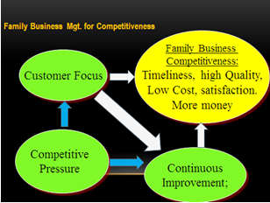
The figure below shows how that process leads to family business success.

Summary

- Many businesses in Zambia and in the world were started as family business entities.
- Most Health Shop businesses are family businesses.
- A business must have a strong customer focus to be successful.


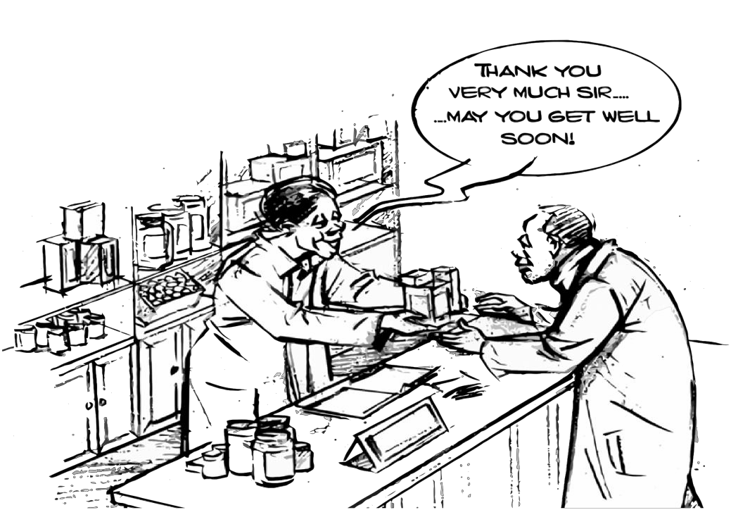

Session 2: Succession Planning in Family Business

A significant challenge faced by multigenerational business-owning families is the transition from generation to generation. Most of the successful family businesses have invested heavily in educating younger family members in the dynamics of the business, and literally groomed them from childhood to take on key roles.
“Succession planning is a process for identifying and developing internal people with the potential to fill key business leadership positions in the company.” (Wikipedia - https://en.wikipedia.org/wiki/Succession_planning)

- You identify potential by observing:
        - How people work
        - How they interact with others
        - Whether they help others or only themselves
        - Whether they put the needs of the business first
- You develop potential by:
        - Providing guidance and support
        - Providing opportunities to contribute to the business
        - Rewarding good work
        - Expecting the best
- Leadership is
        - Modelling what you expect from others
        - Identifying and developing potential
        - Bringing out the best in others
        - Working for the success of all

“If the business is to survive as a viable enterprise in a competitive marketplace and remain family-owned, the family must not only engage and educate succeeding generations, but also encourage an entrepreneurial mind set.”

Summary

- Involvement of the next generation in a family business represents a competitive advantage.
- A viable family business needs a strong leader and a supporting governance structure and systems.

Session 3: Critical Success Factors in Family Business

Critical success factors for a family business include:

- Multigenerational leadership
- Great communication and conflict resolution skills
- A well thought through business plan that is sensitive to the different personalities and temperament of the business. (Note: in Module 4 we will examine how to develop a business plan.)
- Family management systems need to be formalized to ensure they drive success for the long haul.
- Wise long-term investments.

Successfully balancing the differing interests of one or more family members, on the one hand, and the interests of the business, on the other hand, requires the people involved to have the competencies, character, and commitment to do this work.

Summary

- Family business survival is dependent on a combination of outstanding business acumen and visionary leadership.
- The family members may have different interests.
- Family participation as managers and/or owners of a business can strengthen the business since family members are often loyal and dedicated to the family enterprise.
- However, having family members as managers and/or owners of a business can also present unique problems because the dynamics of the family system and the dynamics of the business systems may not be in balance.

MODULE 4: HEALTH SHOPS BUSINESS PLANNING

This module is dedicated to helping the Health Shop owner understand the importance of a business plan in guiding business operations and generating business finance and profits. Many microenterprises and small businesses operate without the guidance of a simple business plan. A business plan is not only used to obtain bank loans but is a key guiding document for any business enterprise.

Session 1: Introduction to the Concept of Business Planning

What is business planning?
Business planning means defining a deliberate, focused growth path that helps guide you as you start your business, help it grow, and make it successful. You follow a business planning process to develop your business plan, which will detail how to start your business, what to sell, who to sell to (your customer), costing and pricing, financing options, how to operate profitably, and how to grow your business in the long term.

A business – even the smallest business - needs a plan if it is to succeed. This plan is like a road that you follow when travelling. If you want to move from here to the next village, you must know how to get there, which means knowing what road to take, whether you will travel by foot or by bicycle, how long it will take you, with whom you will travel, what supplies you will need, etc.

As we will see in the next section, a business plan is based on two key factors, namely, the vision of the business (where the owner/business should be in the future) and the mission of the business (what you do to achieve your vision).

Summary

Your Health Shop needs a business plan because it will:

- Help define the overall direction of the developing the business.
- Help set realistic financial and non-financial targets.
- Enable the owner to plan for and track growth.
- Help identify the most appropriate structure and systems.
- Assist with raising financing (because a good plan will interest a potential investor).

Session 2: Key Components of a Business Plan for a Health Shop

Business vision and mission

A business plan begins and is heavily guided by two factors, which are the vision of the business and the mission of the business.

    - The vision is the mental picture of the future you want.

If in your mind, you see a village where everyone has access to affordable quality medicines, then you set out to achieve that. Your reasons for starting a Health Shop business are inevitably linked to your vision of the type of society you want to live in.

Once you have that vision (the mental picture of the future you want), write it down. This is called your vision statement.
For example, Musonda Health Shop could have its vision statement as:
Our vision is that our community is a place where everyone has access to affordable, quality medicines.

- The mission is what you do to achieve a vision.

If your vision is a village with affordable, quality medicines, then your mission will be to ensure that affordable, quality medicines are available to the community in that village.

Once you have your mission (what you are going to do to achieve your vision), write it down. This is called your mission statement.

Musonda Health Shop could have their mission statement as:
Our mission is to engage in a profitable medical drug business to ensure a steady supply of quality medicines to our customers.

Session 3: Key Components of the Business Plan

A Health Shop Business Plan should include the following key components:
Background

- Vision
- Mission
- Business environment (opportunities and threats)
- Business status (strengths and weaknesses)
- Business location (physical address) and contact information

Sales and Marketing Strategy

- Description of your potential customers
- Your current competition
- Your competitive advantage. Key areas to consider are: price, quality, delivery, customer service, terms of business, other features or services.
- How will you promote your business? What, where, when, how, and why are you going to market your service to your potential customers to best effect (and how much will it cost?).

Supply or Procurement Plan

Key factors to consider here include the following:

- Who our suppliers are or will be.
- How many potential suppliers there are.
- How far away the suppliers are.
- How long it takes to receive orders.
- What the terms of supply will be: cash or credit terms.
- What the terms of delivery will be: the wholesaler delivers or we pick up from them?
- The mode of transport we will use.

Stock Management Plan

Stock management is a key factor in the drug business. The business plan must clearly state how this will be handled.

- The type of medicines to be stocked.
- How much of each type to stock.
- The minimum stock for re-ordering.

Staff Plan

The staff plan looks at the number and type of staff to employ. This is determined by the size of the business and the number of customers served. In a Health Shop that is managed by the owners, some key staff to consider include:

- Dispenser
- Cashier/Accountant
- Cleaner

The business plan will provide further guidance on whether or not employees will be family members. This is further determined by the size and age of the business or the agreed-upon mode of business operations by the business owner.

Business Growth and Expansion Plan

A good business plan should include how the business will grow:

- Whether it will be opening more shops or branches.
- Whether it will be expanding the business in the same premises.
- Whether it will provide additional products and services.

Community Responsibility Plan

This is both a policy and a component of a business plan. It states how much money the business will spend on community responsibility or good causes. This is important because if it is not planned and well managed, it may lead the business into losses. The easiest way to determine this is to:
- Set a ceiling that is the maximum amount the business will donate.
- Respect this ceiling.

If a business plans to spend one thousand kwacha on community responsibility, it should be this amount. It can be spent as lump-sum or spread across many causes.

Summary

    - A business plan has seven key components.
    - A business plan is a living document that must be updated periodically.

Session 4: The Business Financing Plan

The business financing plan must accompany your business plan. It includes detailed information about your business finances.

Key Objectives and Financial Review

Under the key objectives and financial review section of your business plan, you should include the following information:

- Financial objectives: These can be in the form of sales or profit targets. You could also list your main financial management goals, such as cost reduction targets.
- Finance required: Enter how much money you need up-front and include:
- From where you’ll obtain the money.
- What portion you’ll be seeking from loans, investors, business partners, friends, or relatives.
- How much of your own money you can contribute to the business.

Financial Projections

For a Health Shop, a key consideration when starting a business is seed capital or growth capital. This is the amount of money that one needs to start or expand the business. It is usually spent on the three key investment areas:

- Rent or building premises
- Furnishings
- Working capital (= assets less expenses or what money is left after everything is paid at the end of the month)

Sources of Business Finance

The major sources of finance for a business include the following:
- Savings
- Credit from family, friends
- Reinvested profits
- Supplier credit
- Customer advance
- Selling assets
- Overdrafts
- Loans

Savings
This is the most reliable source of business funds. It is determined by how you set your life goals and financial goals. Remember the matrix on age and goals/achievements? If your goal was to become an investor at 45, then it means that you should have started saving at age 25. The richest man in Africa, Aliko Dangote, is still starting new businesses, even when he is past 60 years.
So at whatever age, the formula works: if you save 20% of whatever income you get, you will be a millionaire in 20 years. And these savings will give you start-up capital for investment.

Credit or grant from friends and family
This is another reliable source of starting capital or expansion capital. Once you receive a soft loan from family (friends or relatives), make an effort to pay back, even if it is in small instalments. This will help you establish an image of an honest and credit-worthy person. Such an image is one of the biggest assets in life and business.

Reinvested profits
This is the most reliable and secure source of business finance. It means the business is growing organically, on its own strength. To achieve this, the business must state clearly in its business plan how profits will be used: what percentage goes to shareholders, what percentage goes to grow the business.

Supplier credit
Supplier credit is when you do not pay cash for your stock. The supplier gives you an agreed-upon period within which you will pay. It is a good source of business finance but it depends on two key factors: honesty and good management. Honesty means that you will be trusted that you can pay back. Good business management enables you to earn the money to pay back. When you receive goods on credit, it means you can charge affordable prices, get more customers, and thus more sales. This is the secret behind the success of most Indian small businessmen. They receive goods on credit but they pay back to their suppliers.

Customer advance
This is when a customer pays for medicines in advance before taking them. If you do your marketing well, and you are a trusted businessman, it is possible to get customers depositing against their future medical needs. It can be a school depositing on the account for their students’ medical needs, or a family head who travels frequently and needs to ensure his family has emergency medicine when he is away. There are several potential customers in this category, if you do your marketing well.

Selling assets
This is normally done when one is seeking starting capital. Any asset can be sold, as long as the money obtained is invested and it earns profits. What you sell today can be bought tomorrow. The challenge here is when it comes to family assets, getting the agreement of everybody is not easy. There is still the culture of sentimental attachment to things. But when you have a clear business plan of what will be done with the money, it becomes easy. As one wise man has said: “the only thing you cannot sell is your wife and your children…”.
Overdrafts
If you are a good regular customer of your bank, it is possible to get an overdraft. This is normally needed for short-term financial needs and operations.

Loans
Loans are the most common form of bank credit. It will be easy to get a loan if you keep records and your business is profitable. One key fact about loans is that it must be used for the business it is borrowed to finance, not for other purposes. Large long-term loans are normally needed for investment capital, such as opening a new branch, or expanding the existing business.

Summary

- All planned activities in a Health Shop require an accompanying financing plan.
- The financing plan of your Health Shop is a core component of your business plan that will guide your Health Shop on the most appropriate ways of financing the business.
- The financing plan is a more comprehensive version of a budget because it provides guidance on potential sources of financing for the various aspects of the business, while a budget provides you with the anticipated costs involved.
- A financial plan will help you to determine cost price, your profit margins, and therefore, enable you to determine the required sales projections that will ensure that you run a profitable and sustainable Health Shop.

MODULE 5: BUSINESS MANAGEMENT

Session 1: Costing and Pricing

Introduction of Key Concepts and Discussion

Business Costing and Pricing

Business costing establishes a selling price that is informed by how much you spend on running your business. This is important because it helps the business to determine the price at which to sell in order to make a profit. You can only know whether you are making a profit, or a loss, if you know how much you spend on the business. There are two types of costs: fixed costs and variable costs. One of the most common fixed costs is rent. Variable costs include the cost of stock and labour.

- How does a Health Shop business determine at what price to sell?
- What factors are considered in the pricing of a tablet of Panadol?

The simplest method of costing is called “cost plus.” This means adding a percentage to the cost, to get a selling price.

Pricing

Pricing means determining the price at which to sell. A business will always want to make a profit. Pricing therefore means adding an extra amount of money to the cost price, to get the selling price. The difference between the cost price and the selling price is the profit.

In the example below, Musonda Health Shop has its cost per tablet as 5 kwacha. Using the simple formula of cost plus, the business owner can add 3 kwacha and sell each tablet at 8 kwacha. She/he may add 5 kwacha and sell each tablet at 10 kwacha.

One important thing to consider in setting the selling price is to assume that the buying price will have increased when you go to buy again. This means that if the cost of one tablet was 3 kwacha in August and you plan to buy stock again in October, you will need to plan on your cost being higher then.
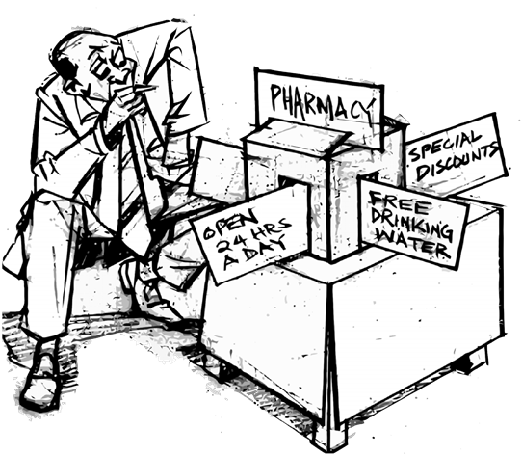
Example: Musonda Health Shop had the following costs for the month of August 2016:
Cost Area | Unit Price (ZMK)
Stock | 5,000
Rent | 500
Salaries | 2,000
Transport | 500
Miscellaneous expenses | 500
Total | 8,500

To get the cost of each tablet, we count all the tablets, divided by the total cost.

Assuming the total number of tablets in stock is 1,700. We divide 8,500 by 1,700 to get the cost of each tablet.

8,500/1,700=5

The cost of each tablet is 5 kwacha.

    - Costing is the way you calculate how much each individual product costs you to produce and sell.
    - Pricing means deciding on the price that you charge for your products.
    - Your price is determined by all the costs involved in producing and selling the product.
    - If you sell your product for a price that is higher than the costs to make and sell your product, then you are make a profit.
    - If you sell your product for a price that is lower than your costs, then you are sell at a loss.
    - Price is determined by the following factors:
  - The cost price of each product.
  - The desired profit.
  - The price other people are selling the same product for.
  - The maximum price people are prepared to pay.
  - The price determined by the market.

Session 2: Buying, Receiving, and Transporting Medicines

Buying Medicines

In the introductory module for this course, we noted that the Health Shop business is a unique type of business because it involves saving lives. This means that medicines cannot be purchased from any source. They must not be transported in any way you find cheap and easy. They must not be handled in any way that you find okay with you. The focus of this session is on the key things you need to learn and master when it comes to buying, receiving, and transporting medicines.

Who are your suppliers?

It is more profitable to purchase your supplies from the nearest wholesale pharmacy or a drug manufacturer. The pharmacy must be licensed and authorized by the Zambia Medicines Regulatory Authority. If there is no licensed pharmacy in your area, you will have to travel to the nearest town where you can buy medicines from a wholesale pharmacy. Some pharmacies do both wholesale and retail. Don’t make the mistake of buying from the retail counter, which will be much more expensive. It is more profitable to buy at the wholesale price.

Other factors to consider:

- What terms does the wholesaler offer?
- Do they offer credit terms?
- Do they offer transport or delivery?
- Do they prefer payment by cash, transfer, cheque, or mobile money?

These factors are important. A supplier who offers you credit terms is an asset to your business.

Where are your suppliers located?

The distance from your suppliers to your Health Shop is important. It determines how soon you can get your stock.

- If your supplier is nearby and always has stock, it means you don’t have to tie up capital in slow moving medicines. You only stock the minimum necessary and buy from the wholesaler once your stock is getting low.
- If your supplier is far away or often does not have stock, it means you may have to tie up capital in slow moving medicines. You have to stock more than the minimum and be sure to buy ahead of time.

Receiving Medicines

- Many times, receipt of medicines will be done from the pharmacy where your medicines are purchased.
- On rare occasions, the medicines may be delivered by your supplier to the drug shop premises.

Receiving Medicines Checklist

When you receive medicines, do the following:

- Check the quantity supplied on the invoice or receipt against the quantity ordered from the wholesaler.
- Ensure that the quantity supplied equals the quantity ordered.
- Check the medicine strength supplied against the one ordered.
- Ensure that the strength supplied is the strength ordered.
- Check the expiry date of the medicine delivered.
- Reject medicines with short expiries.
- Reject medicines that do not have an expiry date.
- Check the packaging materials to make sure they are all intact.
- Reject medicines whose packaging materials are not intact.
- Check for the brands on the purchase list with those supplied.
- Reject medicines that are not your preferred brand.

Transporting Medicines

While it is good practice to minimize costs of transport, sometimes it may be dangerous to transport medicines in a taxi boot or on the roof, mixed with other goods. Most wholesalers of medicines do have their sales vans, so it is advisable to buy from those wholesalers whose vans can deliver the medicines to your shop. If it is not possible, then make sure that when you use public transport, your medicines are carried in the most hygienic and safest way possible. If they are well packed, place them by your side, pay for the seat where you place them, instead of putting them in the back or overhead carrier. If your supplier is nearby, you can use a bicycle or a motorcycle to carry the cartons, but they must be covered to protect them from dust.
Factors to consider when buying and transporting medicines include the following:

How do you transport your medicines from the suppliers?

Transportation of goods by retailers in Zambia’s rural areas is not yet fully developed. Cargo is transported as luggage in passenger vehicles. While other goods can be transported in bus boots or on roof tops, medicines need special handling. They need protection from rain, sunshine, dust, excessive heat, humidity (wetness), and other harmful conditions.

Session 3: Stock Management

Stock management is a key operation for a drug shop. Stock management is the implementation stage of the procurement and supply plan, as well as the stock management plan. Remember that a business needs a plan to succeed and grow profitably. Medicines are delicate. They will save lives if stored well. They can cause serious harm to people if poorly stored. Harming clients means harming your business as well. Therefore, a good Health Shop business person must know stock management.

Type of Medicines to Be Stocked

Health shops stock the category of medicines in the general sales list or registered medicines, and in the prescribed list of medicines for Health Shops outlined in the Health Shops regulations in SI No 12 of 2016.

How Much of Each Type to Stock?

The quantity to stock of each medicine class or brand is determined by the rate of turn over: which ones move fast? Which ones move slowly? It is prudent to stock a maximum of the fast movers and a minimum of the slow movers. This has two advantages in the medicine business: one, you reduce the risk of medicines expiring while in stock, and two, you minimize the amount of capital tied up in stock. Money invested in stock is supposed to earn more money in the shortest time possible.

The FEFO Rule

The FEFO rule states: “First expiry, first out.” In other words, the medicines that are first to expire must be the first to be sold. If you have two or more containers of a particular medicine to be dispensed to a customer, you should dispense the container whose expiry date is the soonest.

The FIFO Rule

The FIFO rule states: “First in, First out.” Like the FEFO rule, it must be followed if you are to avoid having goods, especially medicines, which are so important and can be so expensive, expire. This means that when you have containers of a particular medicine that all have the same expiry date, you should sell those that were received and stocked first before those that were stocked later.

Example: Coartem that was stocked two weeks ago must be sold before Coartem that was stocked two days ago.

It becomes easy to follow this rule if the medicines are stocked and arranged according to their expiry dates. Medicines due to expire in December 2017, for example, must be placed before those due to expire in June 2018.

You may create a simple formula to follow in order to obey this rule. For example, it could be:

We stock from left to right, beginning with the latest date.
We sell or dispense from right to left, beginning with the oldest date.

What Is the Minimum Stock For Re-ordering?

A good Health Shop business must not run out of stock.

The simplest rule for not running out of stock is:
    - 80% fill rate for the fastest moving medicines
    - 60% for the next fastest
    - 40% for the next
    - 20% for the slow movers

“Fill rate” means the minimum stock you should have.

For example, 80% fill rate means that if 10 people come in to buy Coartem, you should have enough doses to serve at least 8 out of the 10 people. Therefore, once your stock reaches 8 doses of Coartem, where you should have 10, then place your order for more. This means that by the time you receive more stock, you will still have enough stock.

Remember: If a customer fails to get a particular medicine from your Health Shop twice, he or she will move to your competitor. This dissatisfied customer will not come back, and will tell five more customers that your Health Shop has no medicines!

How Do You Determine Which Are Fast Selling or Slow Selling Medicines?

This is one area where recordkeeping is important, as we shall discuss in the session on recordkeeping. If you keep good sales records, at the end of each week or month, you will be able to know how each medicine type or brand moves. Records should also include lost sales.

What Are Lost Sales?

A lost sale is when a customer asks for a medicine that you don’t have in stock. If in one month, there are 10 lost sales for one medicine, then it means that this medicine is needed, so you should include it in your stock orders.

Stock Control System Steps
- Receive your stock
Count and check the condition of the products supplied against the invoice or delivery notes, if available.
- Record your stock
Write down all products coming into and going out of your store. Follow the rule of FEFO or FIFO.
- Store your stock
Keep the right amount of stock in a safe, temperature-controlled (if necessary), and practical way.
- Check your stock
Check and count your stock often to make sure that it is in good condition, it has not expired, and no stock is missing.
- Arrange your stock
Arrange your stock so that it attracts customers to buy it and so that it is easy to count.
- Re-order your stock
Re-order the right stock, in the right quantity, and at the right time.

Stock Records

The simplest form of stock recordkeeping for a Health Shop is a stock card. There are two types of stock cards: a pre-printed stock card or a “home-made” stock card. A home-made stock card means that the shop owner creates his or her own stock card. It can be easily made from an exercise book or a counter book. An example of a page in a counter book would look like this:

DRUG NAME: Coartem
Date | Quantity In | Quantity Out | Balance | Expiry Date
15 .8 .17 | 20 |  | 20 | 14 .4 .2018
16 .8 .17 |  | 5 | 15
18 .8 .17 |  | 7 | 8
25 .8 .17 | 20 |  | 28 | 14 .4 .2018  21 .8 .2018
31 .8 .17 |  | 9 | 19

You can allocate about four pages per month for each brand for fast movers, while one page can be enough for slow movers.

Prescribing and Dispensing Log

It’s a document that is used to keep records of all controlled drugs administered, dispensed or otherwise disposed of.
The Health Shop owner must be able to document what medicines clients have received, how much, and when.

The Health Shop owner must also document the date, client names, age, sex, address, diagnosis, treatment, cost of the medicine, person who prescribed the treatment, and the person who dispensed the medicine, all this information in the prescription and dispensing log.

Ordering Stock

If you buy from the sales van, they will have their delivery book, where all your purchases are recorded on the delivery note and you sign.

If you buy from the wholesaler’s shop, you need to have a stock order form, where you write down the types and names of medicines you need to purchase.

In case you order by phone or any other means, then you will need to check the stock delivered against what you ordered.

Stock Taking

Stock taking enables the Health Shop to know how much stock is in the business, both in terms of goods and money value. Stock taking also helps to eliminate dead stock. Dead stock means medicines that are about to expire or those that have expired. It is usually done at the end of the year. The closing stock for December 2016, for example, becomes the opening stock for January 2017.

Inside Your Health Shop

Space management is another key management practice in a Health Shop. The most common form of medicine storage and display is on shelves and in counters. Following the FIFO rule and the particular formula you have adopted, fast moving medicines should be the nearest, where you can pick them even without leaving your seat. Slow movers should be at the end, or could even be kept in cartons and placed in a specific corner. The shelves need to be made with a stopper-rail running across each base of the shelf, to prevent bottles or boxes from falling down.

Housekeeping, Merchandising, and Hygiene

Your Health Shop is a business. Business is competitive. You need to attract and keep customers. One key factor that determines a customer’s choice of drug shop will be the general ambiance (inside environment) of your shop. However small, make sure your shop is very clean, tidy, and attractive to the eye. Most OTC drug manufacturers have advertising materials, such as posters. You can use these creatively, to improve the ambiance of your shop. Place them at strategic points where they appeal to customers entering the shop.

Hygiene in a Health Shop is very important. The shop floor, the shelves, and the counter need to be cleaned and mopped regularly. Take advantage of any free moment when there are no customers in the shop to clean up. Whether one person (the owner) or with staff, it is important to be clean. You have been trained on best practices in dispensing medicines, but we need to emphasize it here as well from a business perspective.

Summary

- Housekeeping, merchandising, and hygiene
- Stock taking
- The FIFO Rule
- The FEFO Rule
- Ordering for stock

Session 4: Marketing and Customer Care

Marketing can be simply defined as efforts by a business to keep attracting and retaining customers. Attracting and winning customers means getting them to buy from you. Keeping customers means that these customers have made you their only or preferred source of accredited medicines. Keeping customers is actually harder than winning or attracting customers.

Attracting or Winning Customers

Attracting customers begins with making them know that you have what they need, where to find it, and at a price they can afford. These are the 4 Ps of marketing. The first P is Product (medicines), the second P is People (customers, staff), the third P is Place (location of your Health Shop), and the fourth P is Price (the cost of medicines).

- Product: The product is what attracts customers. You must stock the required medicines needed in your market of operation. Remember the discussion on business environment at the beginning of this course. If you identify the opportunities well (the needs of the market), then you will stock the right medicines. Another key factor about product is to know which medicine treats what disease. If Cofta is not available, what is the alternative medicine? Do you sell genuine medicines? Are they always in good condition?

- People: The people are the customers you serve. If the area where you operate your business is populated by students and young people, what type of medicines do you stock? If you have mothers with babies, do you stock only tablets and ignore syrups? If you have older people in your area of operation, what medicines will meet their needs? What is the general income of the people? How many can afford brand medicines, and how many can afford generic ones?

- Place: The place is the actual physical location of your Health Shop. The first thing to consider about place is the location of your business. It must be located where it can be easily accessed. It must be visible.

- Price: This is another key factor in marketing. Is your price affordable to your customers? The price must be right for the product. Not too high to chase away customers and not too low to chase you out of business.

Marketing Communications for a Health Shop

Marketing communications is how you reach your customers to tell them about your business. The means you use depends on the type of people you want to receive your message. The action of communicating your business is called advertising.

The very first step to advertise your business is to give it a name, for example, Musonda Health Shop. This should be written in big letters that can be read even from far away on the various media you chose to use as sign posts.

Affordable means you may use to advertise your Health Shop include radio, posters, flyers, and stickers. Envelopes for packing medicines and receipts bearing your business name, location, and telephone number also serve as good advertising material. Radio is the most effective, since it reaches the largest number of people, including those who cannot read or write. Posters can be placed in strategic places, while stickers and flyers can be distributed to homes, schools, taxis, churches, mosques, and markets.

Rules of Effective Advertising

- Use the language most people understand.
- Use few, clear words.
- Use clear pictures/diagrams.

Keeping Customers

We noted at the beginning of this session that marketing aims at two things: attracting customers and keeping those customers. Your business will only grow if you can keep the customers that you attract. If you keep losing customers, then your business will eventually collapse. Customers are very easy to please, and therefore easy to keep. Remember the eight stakeholders of your business that we discussed in the first module? Who is number one? It is the customers. And what do they expect? The only thing you need to do to keep your customers is to know what they expect and give them what they expect.

Customer Expectations

Customers expect the following:
- Quality medicines: your medicines must be genuine (not fake) and not expired.
- Fair, affordable price: They must not feel that you are over-charging them. Remember, there are other Health Shops where they can compare prices.
- Service with a personal touch, respect, and care.

Tips to Keep Customers

- Always welcome customers with a greeting and a genuine smile.
- Make an effort to know your customers by their names (most are neighbours).
- Attend to them quickly, even if you have many waiting.
- Ensure that you can answer all their questions about the medicine they need.
- Have a clean comfortable place where they can sit while waiting.

Summary

    - The most effective means of marketing your business is by word of mouth by your satisfied customers.
    - An angry customer will tell five people about your “bad” business.
    - The only thing you need to do to keep your customers is to know what they expect and give them that.
    - Treat customers the way you would like to be treated if you went to someone’s shop.

Session 5: Business Leadership and Ethics

The purpose of this course and training is to enable you have the skills to grow your business while making profits. Setting a vision and setting goals for the business are what business leadership is all about. The founder of the business, the entrepreneur who started the business is the one to provide leadership for that business to grow. Business leadership means providing:

    - A vision (long term) for the business.
    - A direction (day-to-day operations) for the business, for it to move and reach its vision.

A good business leader, who leads his business to success must:

- Think big and long term
- Be creative
- Focus
- Sacrifice
- Inspire
- Motivate
- Make decisions
- Take risks
- Practice and promote good ethics

Business ethics starts with the business owner. A bad person will not run a good business and sell good medicines. If you are bad person, the neighbours know.

Ethics simply means doing the right and good thing: Doing to others what you would like done to you. Ethics is important in a Health Shop business because the business involves saving lives.

Some actions of good business ethics include:

    - Selling the right medicines.
    - Selling medicines that have not expired.
    - Selling at the right price.
    - Advising customers if the medicine they need is not available, instead of telling them …this one also can work.
    - Honesty when dealing with people who may not know much about medicines.

Summary

    - Leaders have the responsibility for ensuring high moral and ethical standards in a Health Shop business.
    - Good business leadership does not only focus on business competence, but also on ethics and people transformation.
    - Ethical leadership respects the rights and dignity of others.
    - Ethical leaders ensure that ethical practices are carried out throughout the Health Shop.
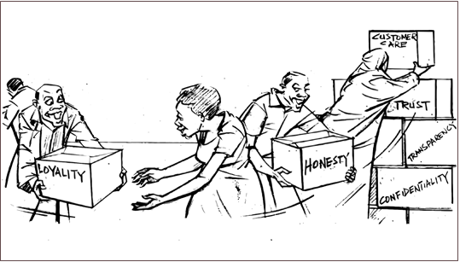

Session 6: People Management

“Management is nothing more than motivating other people.”

People management is the ability to communicate effectively with people you work with
(employees, suppliers) in order to get the job of the Health Shop done. People management invests in building trusting and respectful relationships. People management aims to foster productive interactions.

Steps in Managing People Effectively

- Communicate your expectations.
- Identify your specific goals and targets.
- Determine the timeline required to meet them.
- Determine the role of your team in meeting them.
- Communicate your expectations of them in advance.
- Provide your team with feedback about how well they are meeting your expectations.

- Analyse your team to learn the strengths and weaknesses of each team member.
Take time to understand the strengths and weaknesses of your team.

- Assign responsibilities to maximize the strengths and minimize the weaknesses of your team.
Meet with your team regularly to:
- Provide feedback on people's performance.
- Support the team.
- Enable you to understand the team better.
- Create opportunities for all to consult each other.
- Motivate the team.
- Keep track of team activities.
This helps you:
  - Recognize team performance.
  - Reward good performance publicly.
  - Give constructive criticism in private.

People Management Tips

- Share the vision, mission, and objectives of your Health Shop regularly.
- Share your goals with the team.
- Encourage your team to subscribe to the values of your Health Shop.
- Be consistent.
- Communicate clearly and make goals unambiguous.
- Listen.
- Provide frequent feedback, especially when positive.
- Address any obstacles to your team’s success.
- Be fair, but firm.
- Be consistent and document everything.
- Lead by example.
- Be a role model for your colleagues by being a positive presence.
- Show compassion, understanding, respect, and focus the team.
- Foster a culture of teamwork and dedication.
- Compliment your team.
- Communicate, communicate, and communicate.

MODULE 6: RECORD KEEPING AND BUSINESS FINANCIAL MANAGEMENT

Session 1: Bookkeeping

Bookkeeping means recording the financial transactions of your business. In a small business like a Health Shop, you always need to be in control of the finances. You can help to achieve this by keeping good records―bookkeeping.

Bookkeeping is usually performed by a bookkeeper.

The bookkeeper is responsible for:

- Recording the day-to-day financial transactions of your Health Shop.
- Keeping tabs on purchases, sales, receipts, and payments.
- Ensuring that all transactions are recorded in the correct day book, suppliers’ ledger, customer ledger, and general ledger.

The following records are important for a Health Shop:

- Cash sales book
- Credit sales book
- Cash purchase book
- Credit purchase book
- Receipts
- Invoices
- Bank deposits
- Bank withdrawals
- Prescribing and dispensing log

The bookkeeper brings the books to the trial balance stage, then an accountant may prepare the income statement and the balance sheet.

There are two main reasons to keep accounts:

- To help you manage and grow your business.
- To comply with tax requirements.

Managing and Growing Your Business

Accurate bookkeeping helps you to:

    - Compare your forecasts with actual monthly figures to evaluate your business’s financial health.
    - Analyse your expenses to determine how to operate your business more cost effectively.
    - Discover which are your most profitable customers and/or products and find ways to increase your profit per customer.
    - Detect any problems when you might be straying into cash flow difficulties, so you can act decisively to prevent a crisis.

How to Set Up a Simple Bookkeeping System
(Adapted from Book Keeping for Beginners by Lloyds TSB)

Regardless of how you decide to keep your Health Shop records, certain good practices must always be applied.

- Invoices

- Keep all your invoices and receipts in two sets of files, one for sales and one for purchases.
- Assign a unique reference number to every invoice in and out, and note it in your books or in your computer system.
- Then file the invoices in that order in the relevant folder. That way you can find paperwork quickly if you have a PAYE tax or VAT inspection.

- Expenses
- Keep records of expenses. You can only offset expenses against profits that are wholly, exclusively, and necessarily incurred for the business. So ask for and keep receipts. When you are VAT-registered, it is essential to keep VAT receipts. Without these, you cannot reclaim the VAT element.
- Log the money you have paid in one section of your cash book.
- Assign columns for: Supplier’s name or employee’s name if you are paying wages; Transaction date; Amount; Your own reference number; Cheque number.
- Divide expenses up into columns with headings, such as utilities, insurance, wages, rent, marketing expenses, etc. If you are VAT-registered, you will also need a column for VAT inputs and outputs.
- Add up the totals of each column at the end of each month. Then start a new page for the new month by bringing forward last month’s totals into the columns for this month.

- Income
- Establish another section in your cash book for the money you receive.
- Record your income.
- Note the details of each transaction.

- Petty Cash
- Control your petty cash.
- Keep the float at a constant level, either in cash, or cash plus receipts.
- When you need to top up the cash, remove all the receipts to enter into your books properly.

- Balance Your Account
- Reconcile your bank account at least once a month.
- The steps:
- Start with the previous balance as shown in your bank statement.
- Add all subsequent payments received.
- Subtract all payments made.
- Ensure that the balance matches your latest bank statement.

Session 2: Guidelines for Income and Expenditure Control

What is income?
Money that comes in to your business.

What is expenditure?
Money that goes out of your business.

Sources of business income include:

    - Producing and selling goods.
    - Buying and selling goods (such as in the Health Shop business).
    - Selling a service (like a special hire taxi driver who provides motor transport, or an airline that provides air transportation).
    - Receiving gifts or grants from friends/family members/funders.
    - Bank loans
    - Inheritance money
    - Investors

Business expenditures are made to:

- Purchase products that you sell (medicines).
    - Pay for fixed costs, such as transport, rent, utility bills, taxes, and salaries (including yours).
    - Pay for variable costs, such as repairs, equipment maintenance.
    - Pay for unexpected costs.
    - Pay for investments.

Books of accounts

- This is where the records are first made.
- These books are prepared from source documents (e.g., receipts).
- Examples include:
  - Cash book
  - Sales day book/credit sales
  - Purchases day book/credit purchases

Cash book

- This book records only cash transactions (i.e., cash and cheque transactions).
- Cash coming in is recorded on the left-hand side and cash going out on the right-hand side.
- The format of the cash book depends on whether or not a business operates a bank account.
- The information in the cash book is obtained from the daily record book.

Note: For Health Shops, the prescribing and dispensing log gives a good view of cash transactions to be entered into the cash book.

NOTE: See the examples of recordkeeping tools at the end of this session.

Supplementary advice

    - Keep your business money and household money separate.
    - Effective cash flow management is as critical to business survival as providing services or products.
    - Key methods to help reduce the time gap between expenditures and receipt of income include:
- Customer management through a credit policy that sets out standard payment terms.
- Charging penalty interest for late payments.
- Offering discounts for prompt payments.

Income and expenditure

A business cash book is used to record all the money that comes into (income) and goes out of (expenditure) the business. However, it does not indicate whether the business has registered profits.

What is Profit?

Profit is the difference between the business income and the money spent on producing a good or service or providing goods or services.

Money in – Money out = PROFIT or LOSS

PROFIT means that you receive more money from selling your products than you have spent in buying or producing your products.

LOSS means that you have spent more money on producing or buying your supplies than you receive from selling your products.

How to Calculate Profit or Loss

Step one. From the cash book of the business (receipt side/money in side), total all revenues from sales and other monies received during the period, including credit sales. This will give you total income.

Step two. From the cash book (payment side/money outside), total all payments made (purchases and expenses), including credit purchases. This will give you total expenses.

Step three. Subtract total expenses from total income.

You can then make decisions on the basis of the results in the interest of the business.

Summary

    - A Health Shop business must continually manage profit and loss to remain solvent.
    - Profit is the money the business keeps after paying all of its expenses.
    - Business loss is a result of expenses exceeding the amount of sales the business makes in a particular accounting period.
    - A Health Shop business must manage its income statements (also known as profit and loss statements) in order to keep generating positive earnings and control the business expenses within the generated revenue.

Session 3: Buying and Selling on Credit

Many businesses manage their activities on credit at some point. While buying and selling on credit is a useful practice and can be extremely profitable, it requires a clear credit management strategy. Credit management entails keeping track of who owes the business money, how much is owed to the business, to whom the business owes money (presumably to its suppliers and other service providers), and how much the business owes.

Selling on Credit
Advantage

The key advantage of selling on credit is that it enables you to provide a service to your customers, and therefore, you can attract and even retain customers if you have a credit facility in place.

Disadvantages

- Customers may default on their payments temporarily or permanently!
- If your Health Shop fails to keep track of debtors, the business may become financially unhealthy.
- Credit is money tied down with the customer and can result in the Health Shop becoming cash strapped.

If the best choice is to encourage credit transactions:

- Only permit credit facilities to loyal customers who have built a solid track record of paying up what they owe.
- Negotiate for a down payment.
- Ensure that you have sufficient cash.
- Keep records of all your debtors (the people to whom you sell on credit).

Buying on Credit
Advantages

- Buying on credit is worth it if it will result in generation of larger sales volumes and increased return on investments (profits).
- If you pay off credit in time, it will increase your credit worthiness.

Disadvantages

- In many cases, buying on credit becomes more expensive because of factors like interest.
- It can affect your bottom line.
- It is important that you pay your credit before it incurs any interest and becomes too costly.

NOTE: Credit payments constitute fixed costs.

Summary

- The credit book keeps record of all the money that customers have to repay you and all the money you have to repay to others.
- Your Health Shop can keep two credit books: one for the goods that you have sold on credit, and one of the goods that you bought on credit.
- Each credit transaction must be documented with details of date, nature of goods/services bought on credit, and the money owed to your Health Shop.
- All payments must also be recorded.
- The balance must be adjusted on receipt of payments.

Examples of Recordkeeping Tools

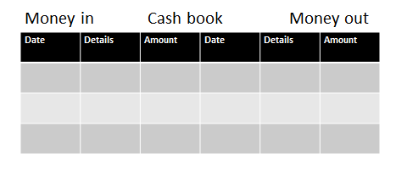
Format for a single column cashbook
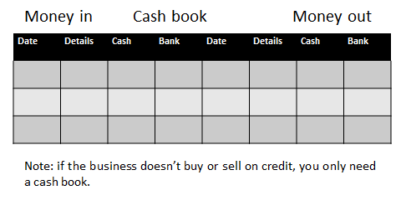
Format for a two-column cashbook
Formats for a debtor’s book
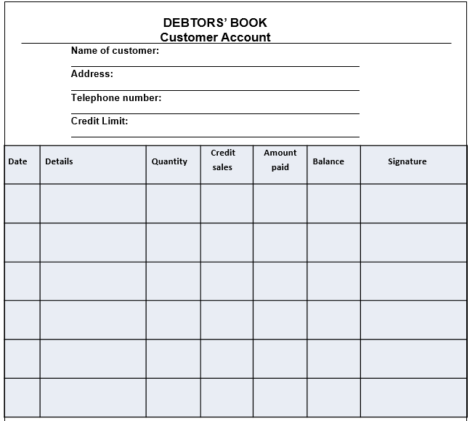
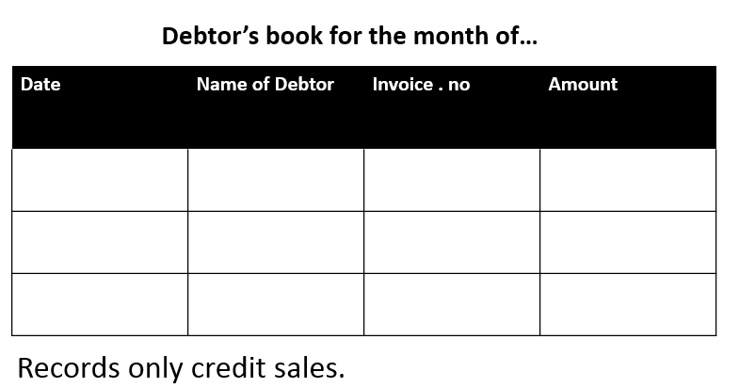

Format for a creditor’s book
